**Introduction**

· SET Operators are used to combine information of similar type from one or more than one table.

· Datatype of corresponding columns must be the same

· The types of SET operators in ORACLE are :

1. UNION : Rows of first query plus rows of second query, less duplicate rows.
2. INTERSECT : Common rows from all the queries
3. MINUS : Rows unique to the first query

**RULES**

1. Number of columns in select statements should be equal.

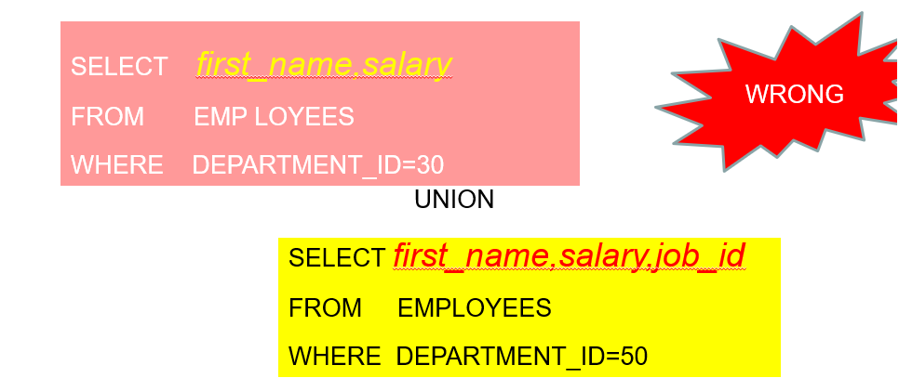

1. Datatypes of the corresponding columns should be the same.

**UNION (Without Duplicates)**

Select to_char(hire_date,'yyyy')

from employees

where department_id=90

UNION

select to_char(hire_date,'yyyy')

from employees

where department_id=60

**UNION ALL (With Duplicates)**

select to_char(hire_date,'yyyy')

from employees

where department_id=90

UNION ALL

select to_char(hire_date,'yyyy')

from employees

where department_id=60

